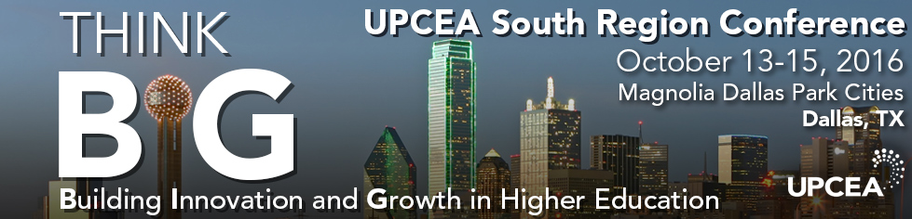

Exhibitor Handbook

Thank you for supporting the UPCEA South Regional Conference in Dallas! We are looking forward to an engaging and innovative event. The following pages include helpful information to make your experience as an exhibitor a great one. If you have any questions or need further assistance, please contact Kim Zaski, kzaski@upcea.edu

Best wishes,

UPCEA

Location
Magnolia Hotel Dallas Park Cities
6070 North Central Expressway
Dallas | Texas | 75206

UPCEA has secured a discounted rate of $161 per night for UPCEA attendees.
The deadline for this discount is September 21, 2016. To reserve your room click here.

Exhibit Space
To ensure you have the maximum opportunity to connect with conference attendees, the exhibitor area for the 2016 UPCEA South Regional Conference will be in the Magnolia 4 room, directly outside of the general and concurrent session rooms.

Arrangement of Exhibits
UPCEA will provide one (1) 6 foot draped table and one chair, which will be supplied by the hotel.
Height Limitation for Displays
Exhibitors shall not display or place any product, sign, partition, person, apparatus, shelving or other construction that extends the size of the table, 72” x 30”. Height is not to exceed more than 48 inches from the table top/8 feet from the floor. Free standing displays may be placed behind the tabletop ONLY and must pertain to the height restrictions.

Exhibit Hall Hours
Please note the follow Exhibit Hall hours. For the complete conference schedule, click here.

THURSDAY, October 13
8:00–11:30 a.m. Exhibitor Setup
12:00–6:00 p.m. Exhibit Hall Open

FRIDAY, October 14
7:30 a.m.–5:00 p.m. Exhibit Hall Open

SATURDAY, October 15
7:30–10:30 a.m. Exhibit Hall Open
10:30 a.m.–1:00 p.m. Exhibit Hall Dismantle

Important Deadlines
Company Logo
- The UPCEA South Region values your support of its 2016 regional conference. To promote your logo on the conference website, mobile app, and program, please submit your logo via the wufoo form by September 10, 2016.
Exhibit Booth Representative
- If you have not already done so, please click here to provide the name of your booth representative by September 10, 2016.

Note: Tabletops include one full conference registration. Additional registrations can be purchased at the corporate member or non-member attendee registration rate via the conference website

Bag Stuffing Items
The UPCEA South Region would like to extend the opportunity for you to provide one item to be included in the conference attendee bag. If you would like to take advantage of this opportunity, items must be received no later than October 10, 2016, and be addressed to:

Alexandra Guimaraes, UPCEA
Bag Stuffing
Magnolia Hotel Dallas Park Cities
6070 North Central Expressway
Dallas | Texas | 75206

Shipments
Exhibitors wanting to ship items in advance may do so by shipping to the facility directly. To ensure that your package arrives in time, please schedule your shipment to arrive no later than, October 10, 2016, at the following address:
Alexandra Guimaraes, UPCEA
Attn: Company Name, Cell phone
Magnolia Hotel Dallas Park Cities
6070 North Central Expressway
Dallas | Texas | 75206

Pre & Post Attendee List
Exhibitors will receive one pre and post list of all the conference attendee’s names and mailing addresses. You can expect the pre-conference attendee list on 15 September and the post-conference list 7 business days after the conference on October 25.

Audio Visual, Electric and Internet
Basic wireless internet is available complimentary in ALL UPCEA space for exhibitors and attendees. If you require additional internet (streaming/hard wired) you will be responsible for ordering and all charges. Electric and Audio visual is not included in the exhibitor package, if you need these items please order using the form attached through the hotel PSAV team.

